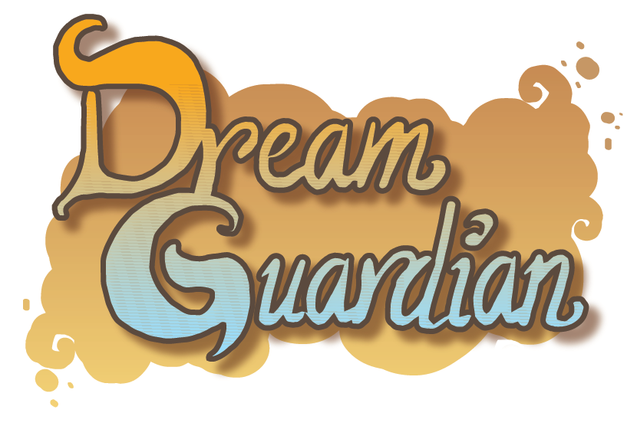

Game Design Document

All Work Copyright @2015/2016 By Dream Guardian Team

Curated By: Federica Agliata

1. **Development Team**



**Agliata Federica**

University of Milan

Master’s Degree in Computer Science

Game Designer

**Ceccarelli Andrea**

****University of Milan

Master’s Degree in Computer Science

Game Programmer

**Celata Tommaso**

****University of Milan

Master’s Degree in Computer Science

Game Programmer

**Celata Michele**

National Academy of St Cecilia

Sound Designer

**Locatelli Nicolas**

****Polytechnic of Milan

Master’s Degree in Computer Science and Engeneering

Game Programmer

**Lubas Cristina**

****Rome University of Fine Art

Bachelor’s Degree in Graphic Design

2D Artist

**Ricci Emanuele**

Rome University of Fine Art

Bachelor’s Degree in Graphic Design

2D Artist

1. **Design History**

04/11/2015 Version 0.1

* Setting GDD’s Guide Lines
* Team data
* Story and Backstory Definition
* Game Structure Definition
* Characters Design Definition
* Start drafting the core of Gameplay

1. **Vision Statement**

Dream Guardian is a 2D platform in which the main character has to protect dreams from nightmare creatures. The protagonist, Yume, the dream guardian has the ability to use “dream sand” and he can shape it in several forms – whips, swords, bows etc.- to fight against enemies and surpass obstacles. The particular nature of dreams is the key of Dream Guardiangameplay indeed, it offers the chance to create very different levels, mixing fantasy with reality. Through different puzzles and particular enemies, Yume will learn new abilities fundamental to overcome particular situations.

Everything fits together perfectly: the background, dialogues and images are coherent to the general gameplay.

* **3.1 Game Logline**

*Play as a Dream Guardian and protect your host’s dreams from shadow creatures of nightmares.*

*Dive into the dream world in an unbelievable enviroment where reality meets fantasy!*

* **3.2 Gameplay Synopsis**

The main aim of the game is to impress players with a mysterious and magical element: the dreams.

Although there is a wide literature about dream and the unconscious during the dormant stage, there are still [very many questions left to be resolved](http://context.reverso.net/traduzione/inglese-italiano/very+many+questions+left+to+be+resolved): Why do people dream just a specific person? Why people tend to dream the same dream over and over again? Could be this dream be a premonition?

Dream Guardian fits precisely in this scientific / mystical duality.

Dreams and Nightmares are essential entities, living in a precarious balance.

The player takes the role of Yume, a hero who fights to defend his world, which is clearly linked to the user’s one, in a dream-real world environment. Thanks to this game’s specifity, the player has the [knack of entering](http://context.reverso.net/traduzione/inglese-italiano/knack+of+entering) into the game’s world, in which he can easily identify himself as the hero, facing situations he faced in the real world – or he could face in the future.

In addition, the game mechanics allow the user to put himself in Yume’s shoes, Yume, and defend a world familiar to him.

The main character, managed by the player, has a set of skills that allows to complete the levels with a good degree of challenge.

From a visual standpoint, each level has a specific theme, a dream of reference, in which everything will be consistent with the environment itself: enemies, objects, actions etc.

The fights against enemies and bosses will increase this feeling of immersion, giving the player the motivation to complete the proposed levels.

In conclusion, Dream Guardian has the aim to let the player live an exciting and engaging gaming experience, not only fun but also thoughtful: moreover, the player can embodies himself in the game, challenging situations that could easily happen even in real life.

1. **Audience, Platform and Marketing**

* **4.1 Target Audience**

Dream Guardian is a videogame that has as primary target pre-teenagers while it is secondly targeting teenagers and adults.

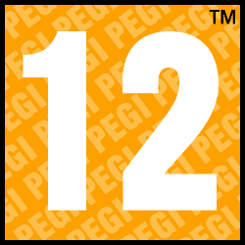PEGI chosen is 12, which implies the presence of a slightly explicit violence towards the game characters. There is no naked associated to sexual activities.

The language is mild and without sex references

The game is not to be considered as a violent one.

For any kind of information about it, we recommend consulting the website of PEGI: [www.pegi.info](http://www.pegi.info).

Dream Guardian promises an enjoyable title to both sexes.

Besides the impact on the population, it does not exclude any Nation because there is no particular reference.

The game is mostly set in a hypothetical Western World, but it does not imply any exclusivity in playability and/or distribution.

* **4.2 Platform**

The platform chosen for the distribution of Dream Guardian is the Personal Computer.

The choice has been taken for several reason:

1) PC is the easiest way for development and distribution

2) It perfectly fits with an indie title

3) Everybody nowadays has a personal computer and uses it almost everyday

4) In case of expansion, online stores (as Steam) could be useful to push the sales

This decision may be subject to future changes.

* **4.3 Top Performer**

**Rayman**

***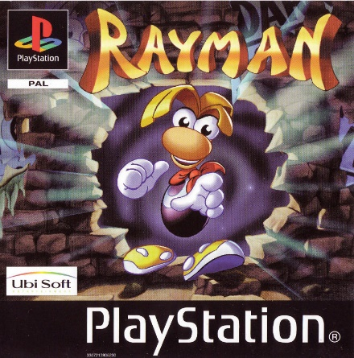*Developer** Ubisoft Montpellier & Ubisoft Milan

**Pubblication** September/December 1995

**Platform** Playstation, Atari Jaguar, Sega Saturn, Microsoft Windows, Game Boy Color, Game Boy Advance

**Digital Distribution** Psn, DsiWare, Virtual Console

**Theme** Fantasy

**Game Mode** Single Player

**Sales Figures** 25 million dollars

**Genre** Platformer

**Units Sold** 3 million

**Plot**

The cosmic balance and harmony of Rayman's world are maintained by a mystical object known as the Great Protoon. One day, the mysterious Mr Dark steals the Great Protoon, defeating Betilla the Fairy as she attempts to protect it. As a result, the Electoons – benevolent creatures which gravitated around the Great Protoon – are scattered across the world. In this now-unbalanced world, hostile creatures appear and imprison the Electoons in cages. The Magician, a benevolent wizard, calls upon the hero Rayman to free the Electoons, defeat Mr Dark and recover the Great Protoon.

**Series**

|  |  |
| --- | --- |
| **Title** | **Pubblication** |
| Rayman 2: The Great Escape | 1999 |
| Rayman 3: Hoodium Havoc | 2003 |
| Rayman Origins | 2011 |
| Rayman Legends | 2013 |

**Super Mario Bros**

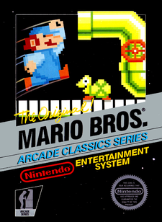**Developer** Nintendo

**Ideation** Shigeru Miyamoto

**Pubblication** September/May 1985-1987

**Platform** NES, Famicon Disk System, Arcade, Game Boy Color, Game Boy Advance, Game&Watch, PlayChoice-10

**Digital Distribution** Virtual Console

**Theme** Fantasy

**Game Mode** Single Player

**Genre** Platformer

**Sales Figures** 40,23 million dollars

**Units Sold** 40 million (only NES)

**Plot**

One day, the [Mushroom Kingdom](http://www.mariowiki.com/Mushroom_Kingdom) was invaded by the [Koopa](http://www.mariowiki.com/Koopa_Troop), a tribe of turtles capable of using powerful dark magic. Their magic was used to transform all the [Mushroom People](http://www.mariowiki.com/Toad_(species)) into inanimate objects such as rocks, bricks, and even horsetail plants, thus spelling the kingdom's downfall. Only the daughter of the [Mushroom King](http://www.mariowiki.com/Mushroom_King), [Princess Toadstool](http://www.mariowiki.com/Princess_Peach), can undo the spell and restore her people back to life, but she is being held captive by [King Koopa](http://www.mariowiki.com/Bowser) himself. [Mario](http://www.mariowiki.com/Mario) hears of the princess's plight, and sets out on a quest to topple the Turtle Tribe and save the once-peaceful kingdom

**Series**

|  |  |
| --- | --- |
| **Title** | **Pubblication** |
| Super Mario Bros: The Lost Levels | 1986 |
| Super Mario Bros 2 | 1988 |
| Super Mario Bros 3 | 1988 |
| Super Mario World | 1990 |
| Super Mario 64 | 1996 |
| Super Mario Sunshine | 2002 |
| New Super Mario Bros | 2006 |
| Super Mario Galaxy | 2007 |
| New Super Mario Bros Wii | 2009 |
| Super Mario Galaxy 2 | 2010 |
| Super Mario 3D Land | 2011 |
| New Super Mario Bros 2 | 2012 |
| New Super Mario Bros U | 2012 |
| Super Mario 3D World | 2013 |

**Castlevania**

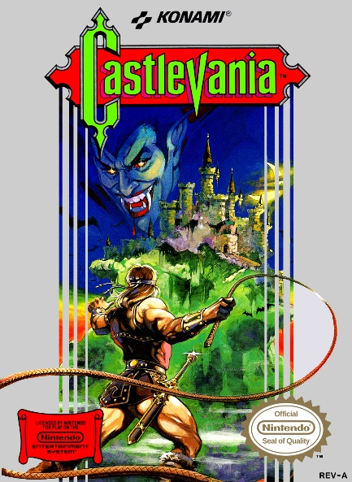

**Developer** Konami

**Pubblication** September/December 1986-1988

**Platform** NES, Famicon Disk System, Arcade, Commodore 64, Amiga, MS-DOS, Microsoft Windows, Game Boy Advance, Mobile Phone, PlayChoice-10

**Digital Distribution** Virtual Console

**Theme** Horror

**Game Mode** Single Player

**Genre** Action, Platformer

**Units Sold** 1,23 million

**Plot**

Castlevania puts players in control of [Simon Belmont](https://en.wikipedia.org/wiki/List_of_Castlevania_characters#Simon_Belmont) as he travels through [Count Dracula](https://en.wikipedia.org/wiki/Dracula_(Castlevania))'s castle, which emerges every 100 years. Simon battles numerous [bosses](https://en.wikipedia.org/wiki/Boss_(video_game)) along his way, including [Frankenstein](https://en.wikipedia.org/wiki/Frankenstein%27s_monster), [Igor](https://en.wikipedia.org/wiki/Igor_(fictional_character)), the [Mummy Man](https://en.wikipedia.org/wiki/Mummy), the [Phantom Bat](https://en.wikipedia.org/wiki/Vampire_bat), [Queen Medusa](https://en.wikipedia.org/wiki/Medusa), the[Grim Reaper](https://en.wikipedia.org/wiki/Death_(Castlevania)), and Count Dracula himself. Simon encounters Dracula in his lair and defeats him. He escapes the castle as it crumbles apart and credits roll.

**Series**

|  |  |
| --- | --- |
| **Title** | **Pubblication** |
| Vampire Killer | 1986 |
| Castlevania II: Simon’s Quest | 1987 |
| Haunted Castle | 1988 |
| Castlevania: The Adventure | 1989 |
| Castlevania III: Dracula’s Curse | 1989 |
| Castlevania II: Belmont’s Revenge | 1991 |
| Super Castlevania IV | 1991 |
| Kid Dracula | 1993 |
| Castlevania Chronicles | 1993 |
| Castlevania: Rondo of Blood | 1993 |
| Castlevania: Bloodlines | 1994 |
| Castlevania: Dracula X | 1995 |
| Castlevania: Symphony of the Night | 1997 |
| Castlevania Legends | 1997 |
| Castlevania 64 | 1998 |
| Castlevania: Legacy of Darkness | 1999 |
| Castlevania: Circle of the Moon | 2001 |
| Castlevania: Harmony of Dissonance | 2002 |
| Castlevania: Aria of Sorrow | 2003 |
| Castlevania: Lament of Innocence | 2003 |
| Castlevania: Dawn of Sorrow | 2005 |
| Castlevania: Curse of Darkness | 2005 |
| Castlevania: Portrait of Ruin | 2006 |
| Castlevania: Order of Ecclesia | 2008 |
| Castlevania Judgement | 2008 |
| Castlevania: Lords of Shadow | 2010 |
| Castlevania: Lords of Shadows – Mirror of Fate | 2013 |
| Castlevania: Lords of Shadow 2 | 2014 |

**Metroid**

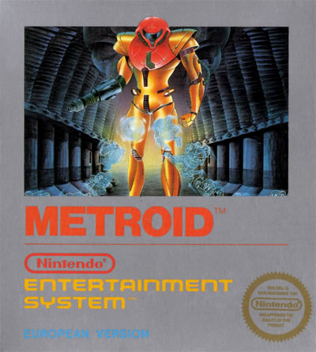

**Developer** Nintendo

**Pubblication** August/January 1986-1988

**Platform** NES, Famicon Disk System, Game Boy Advance, PlayChoice-10

**Digital Distribution** Virtual Console

**Theme** Sci-fi

**Game Mode** Single Player

**Genre** Action, Platformer

**Units Sold** 2,73 million

**Plot**

Chronologically, Metroid takes place first in the fictional Metroid universe. [Space Pirates](https://en.wikipedia.org/wiki/Characters_in_the_Metroid_series#Space_Pirates) attack a Galactic Federation-owned space research vessel and seize samples of [Metroid](https://en.wikipedia.org/wiki/Characters_in_the_Metroid_series#Metroids) creatures. Dangerous floating organisms, Metroids can latch on to any organism and drain its [life energy](https://en.wikipedia.org/wiki/Life_energy) to kill it. The Space Pirates plan to replicate Metroids by exposing them to [beta rays](https://en.wikipedia.org/wiki/Beta_ray) and then using them as [biological weapons](https://en.wikipedia.org/wiki/Biological_warfare) to destroy all living beings that oppose them. While searching for the stolen Metroids, the Galactic Federation locates the Space Pirates' base of operations on the planet Zebes. The Federation assaults the planet, but the Pirates resist, forcing the Federation to retreat. As a last resort, the Federation decides to send a lone [bounty hunter](https://en.wikipedia.org/wiki/Bounty_hunter) to penetrate the Pirates' base and destroy [Mother Brain](https://en.wikipedia.org/wiki/Mother_Brain), the biomechanical life-form that controls the Space Pirates' fortress and its defenses. Considered the greatest of all bounty hunters, [Samus Aran](https://en.wikipedia.org/wiki/Samus_Aran) is chosen for the mission.

**Series**

|  |  |
| --- | --- |
| **Title** | **Pubblication** |
| Metroid II: Return of Samus | 1991 |
| Super Metroid | 1994 |
| Metroid Fusion | 2002 |
| Metroid Zero Mission | 2004 |
| Metroid Other M | 2010 |

1. **Gameplay**

Dream Guardian is essentially a 2D platform-adventure where the player must lead Yume, throughout the levels.

His goal is to save the world of dreams, and to do so will have to complete each Night (level’s group) facing enemies and overcoming obstacles always different.

At the end of each Night, fights with Npc increasingly complex increase the challenge of the title.

* **5.1 Gamplay Description**

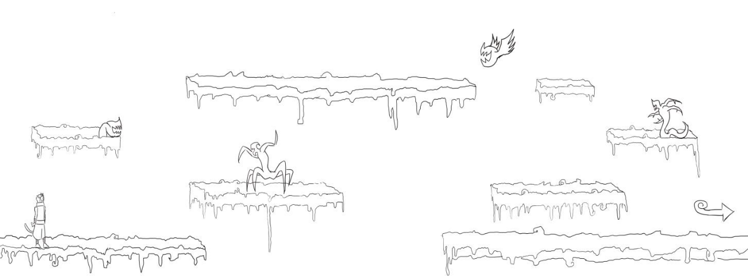After the selection of the Night, the player will start his adventure!

Figure -Starting level, Sample

Yume finally starts his action!

The main purpose, for each level, is to carry it out.

How?

1) Yume can walk, run and jump (base)

2) Yume can use different types of attacks (base)

3) Yume can learn different skills during the Nights

4) Yume has a special attack

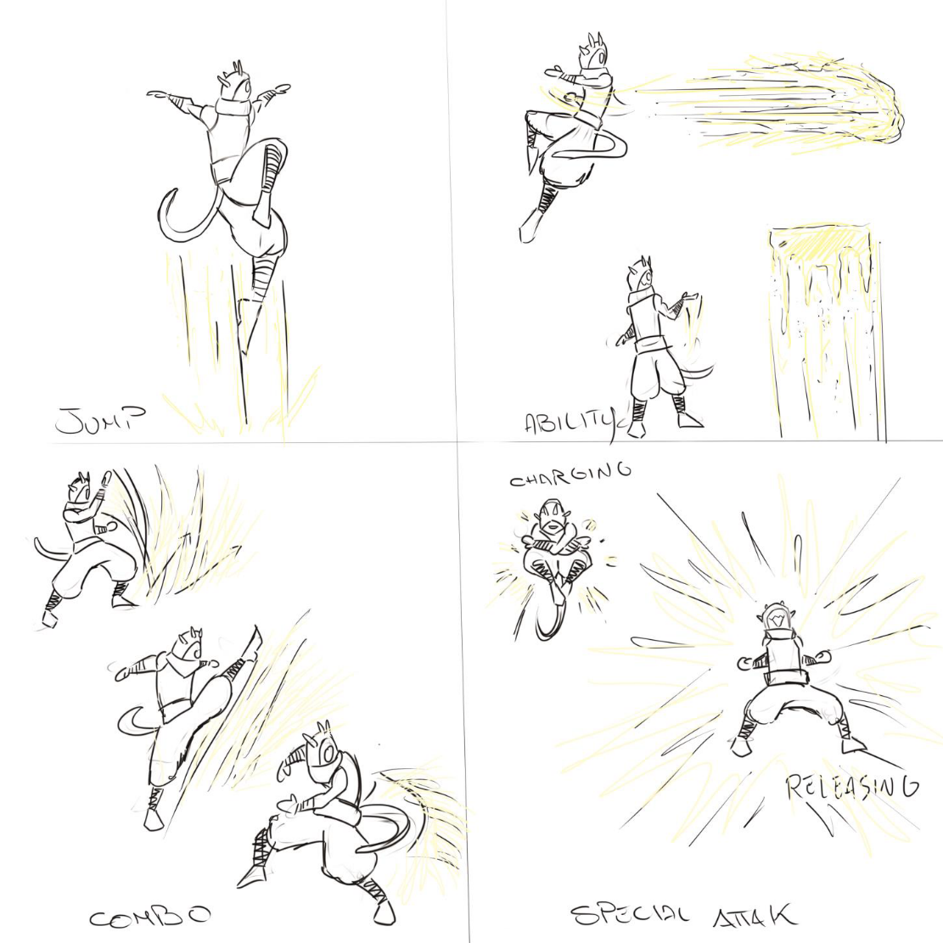

Figure - Different Attacks, Sample

This allows the player to overcome physical obstacles and fight enemies that appear during the level. During each group of levels, Yume will acquire new skills that enable him to overcome new obstacles.

At the beginning of the first level, the skills of the protagonist are limited to physical (base). Its Energy bar, indicating the possibility of special attacks, is so empty.

After the first tutorial our character will unlock a skill and special attack. Both provoke the consumption of the Energy bar, but in different ways: the use of a skill drains less energy unlike special attack that consumes it completely. Once consumed completely or partially, the player can fill it using basic attacks.

The way the player chooses to use these skills will be completely free, it will be only provided a greater degree of difficulty once he learned skills increasingly complex.

Once the player has completed the level, it will pass to the next.

Every Night is constituted by a certain number of levels, the last represent the Boss Fight, after that night is over. (Check Level Design).

The level is completed when the player will arrive at the end of it, unlocking the next one.

A night is completed, when the player has defeated the boss, and thus release the next Night.

* **5.2 Level Design**

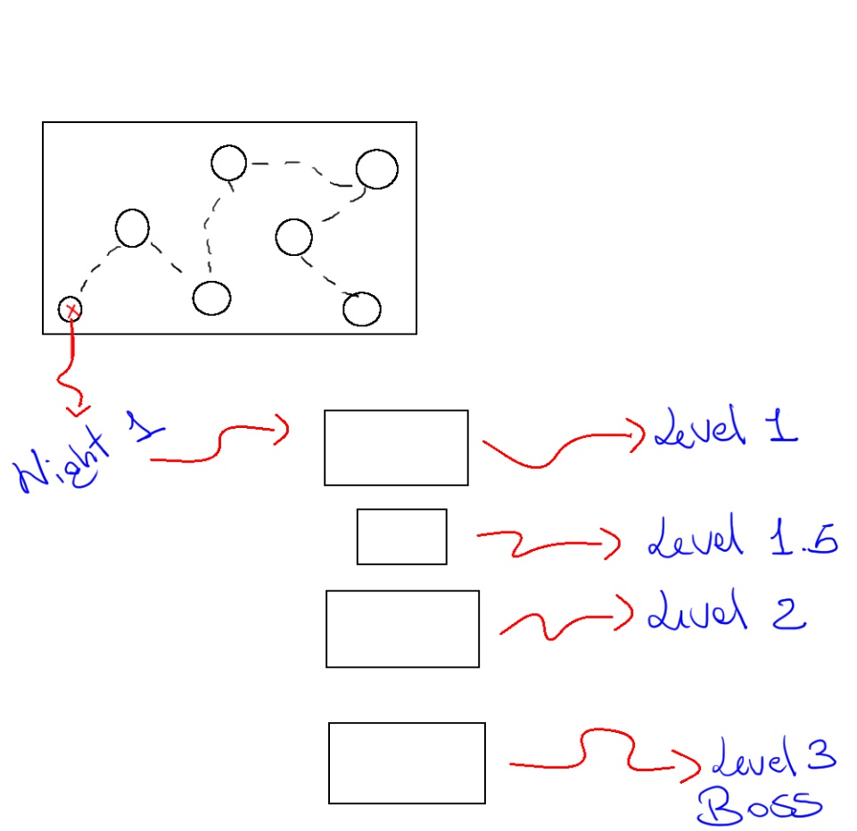

Figure - Levels Structure, Sample

As has been above-mentioned, the leveling structure is built in Nights.

Each Night has is own theme, this means that the theme addressed and the environment used have their continuity for the entire duration of the levels.

As the picture shows, every night is divided into 3 main levels plus a level where the player can learn new skills.

Each of them must be completed in order to unlock the next. In the third level the player will face a Boss Fight, which when exceeded, allows him to unlock the next Night.

Any structural changes will be reported in later changes to this document.

Later all levels designed and developed by the team will be discussed.

1. **Game Characters**

* **6.1 Characters Design**

**Yume**

**Type** Playable Character

**Mission** Save Guest’s Dream

**Look** Strange Creature, Half-Human

**Abilities:**

1. 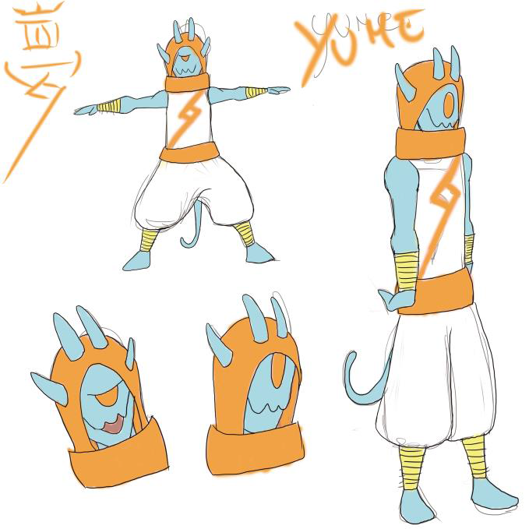Basic Movements (jump,run..)

Figure - Yume, Sample

1. Basic Attacks (punch,kick..)
2. Special Abilities (to do)
3. Special Attack

**Hud** Health, Energy,Special Ability

**Lord/Master of Dreams**

**Type** Non-Playable Character

**Mission** Protect Dream’s World, Train Guardians

**Look** Strange Creature, Half-Human, Old

**Abilities** Teach new powers to Yume. He appears in the tutorial levels

**Lord/Master of Nightmares**

**Type** Non-Playable Character

**Mission** Protect Nightmare’s World, Conquer Dream’s World, Command his Slaves

**Look** Strange Creature (to do)

**Enemy (Standard)**

**Type** Non-Playable Character

**Mission** Protect Nightmare’s World, Conquer Dream’s World, Kill Yume

**Look** Strange Creature (to do)

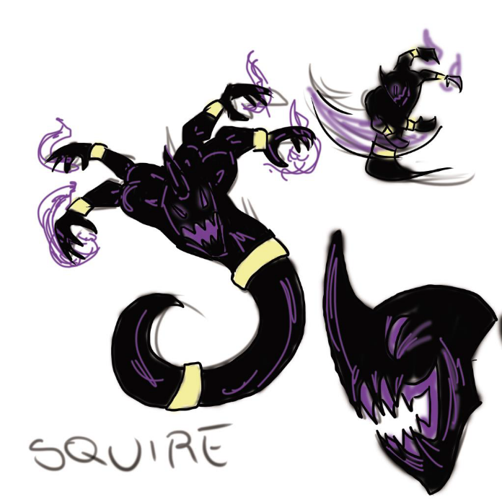

**Enemy (Boss)**

Figure - Boss, Sample

**Type** Non-Playable Character

**Mission** Protect Nightmare’s World, Conquer Dream’s World, Kill Yume

**Look** Strange Creature

1. **Story**

* **7.1 Synopsis**

In a world where humanity believes that dreams are dominated by the unconscious, the Dream Guardians are fighting every day to ensure their safety from the world of nightmares.

Yume, our protagonist, is charged of protecting the dreams of a young boy, that is very important to the emissaries of the world of nightmares. He is indeed a "means" for the conquest of a large network of dreams that would enrich the power of the wicked Lord of Nightmares.

* **7.2 Backstory**

Were thousands of years that such a story was not told…

The world of Dreams and the world Nightmares have lived a long time in equilibrium, one linked to the other, in a perfect harmony.

The Lord of Dreams and the Lord of Nightmares, masters and governors of their respective worlds, trained their guardians in respect of the opposing faction, without prevailing on each other.

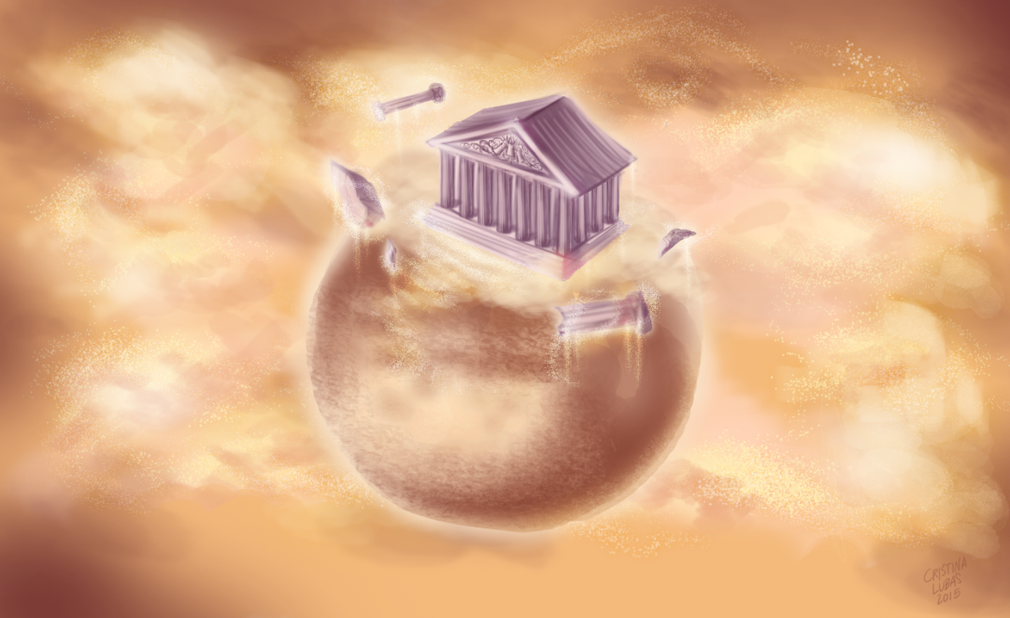

Figure - Dream's World

The Lord of Dreams lived for a long time in the serenity of his Temple along with his followers, the Dream Guardians, aware that not only the dreams must have been part of human darkness, but also the nightmares had their importance.

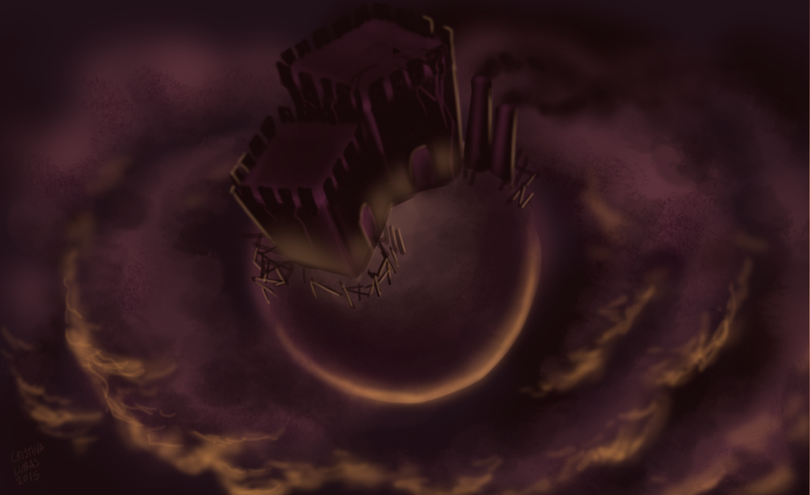

Figure - Nightmare's World

This lasted until the thirst for power of the Lord of Nightmares grew enormously. He was blinded by the possibility of having total control of the world of the subconscious, he decided to go back on his promises and began to attack forcefully human’s dreams, through his emissaries.

The war lasted for a long time, until the Dream Guardians managed to capture him and limit his power.

Despite a long and prosperous period of peace and balance restored, the evil Lord of Nightmares has now found a way to come back to attack the world of dreams!

Indeed, he knew that some humans, known as “powerful dreamers”, are the main channel of communication in the dense network of dreams, and control their dreams means affect those of many others.

* **7.3 Complete Story**

Yume is responsible for the safety of young boy’s dreams, which he is the guardian.

He, like all Dream Guardians, was born with this task and his training focuses on learning the techniques needed to defeat the emissaries of the world of Nightmares, intent to affect the dreams of the boy by monstrous nightmares.

Compounding the situation and the dangers that will face Yume, there’s the peculiarity of his host, who is one of the "chosen" humans able, to channel and connect other dreams, in a totally unconscious way.

This means that them represent portals connecting to the dreams of other humans, so, if emissaries of the world of nightmares attack their dreams they can attack many unsuspecting minds.

* **7.4 Narrative Devices**

The narrative devices we’ll use to introduce and tell the story of Dream Guardian are:

1) Introductory video that will explain the events leading up to the birth of the hero (check Backstory).

2) Growth of the protagonist skills.

His story is told in terms of skills acquired through the training of the Lord of Dreams, in tutorial levels.

3) Change the items in the Level Design. It will denote the content of dreams by: backgrounds, objects, NPC etc.

1. **The Game World**

The game world of Dream Guardian, as we said in the previous paragraphs, takes place in one of the largest collective imagination: The Dream and the Nightmare.

This is not a world completely detached from the reality of the player, but a mirror that amplifies the feelings and memories of the dreamer.

The dream world is in danger and the player has to defend it by one of his guards.

Dreams reflect the experience of the host, and everything in the abstract of the dream has its consistency.

The weather is not very relevant unlike the alternation of day and night. In fact at the end of each night the environment tend to change, preferring the lighter tones, indicating that the host is waking up.

Everything else is closely related to the boy thoughts and dreams.

Additionally, as the nightmares will take power over his unconscious, the environment will inevitably become more hostile and complex to defend.